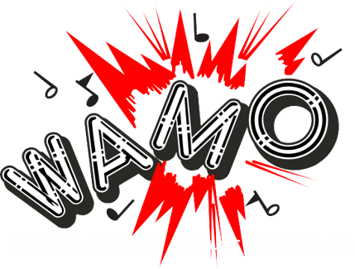

WAMO DART CHARTER

New Charter Fees for 2026 and Beyond

Charter Fee Paid before September 30th: $200

Charter Fee Paid after September 30th: $300

All charter holders (operators) will be held accountable for turning in the proper statistics for the players and teams sanctioned. The charter holder (operator) is ultimately responsible for providing correct information to WAMO for the dart program.

1. Charter Member Requirements:
2. Charter holders must be current with both WAMO membership dues and all other WAMO requirements, including shift buyouts. Any charter holder who is in arrears will not be able to sanction players or enter players in the WAMO State Dart Tournament.
3. Tournament entries must be signed by charter holder. Entry forms will show deadlines.
4. Tournament entries will be limited to 50% of charter holder’s sanctioned teams.

Example: 100 Sanctioned teams= limit of 50 teams to compete in Wisconsin State Dart Tournament. This is for the four-person event only.

1. Player stats must be saved and put into history in the League Leader system for minimum of 2 years.
2. Charter Holder Tournament Work Requirements:
3. Each charter holder must provide volunteer workers for the Tournament. All workers must be at least 21 years of age. The number of workers per operator will be based on the number of team entries that the charter holder enrolls in the tournament.
4. Charter Holder Machine Requirements:
5. Each charter holder may be required to provide dart machines for the State Tournament based on the number of entries per charter. Arachnid/Touchtunes have been supplying new dart boards for the State Tournament, and operators agree to purchase dart boards after the tournament is held. If WAMO needs more boards than Arachnid/Touchtunes can provide, operators may be responsible for supplying their own dartboards. If so, all operator-owned boards must be cleaned and tested before the tournament to ensure that all boards will operate properly throughout the event.
6. WAMO strongly encourages all dart charters to purchase at least one new dart board that was used during the tournament.
7. All WAMO sanctioned teams must play at a location with a valid liquor license, and a valid Federal Tax Identification Number, or the location in question must be accepted and cleared by the WAMO Dart Committee before the first scheduled league match is played.
8. Charter Holders Will Be Required to Follow These Sanctioning Guidelines:
9. Charter Holders must track the achievements required by WAMO for both 301 and Cricket. Either MPR or PPD stats will be accepted. These required achievements are enclosed within the sanctioning packet.
10. Within four weeks of the starting date of your leagues, the dart coordinator (or charter representative) must send a copy of your location report that is provided in your sanction kit, along with a league schedule. See the WAMO website ([www.wamo.net](http://www.wamo.net)) or contact the WAMO Dart Committee for the current mailing address.
11. A player report by league and team must be sent to the Tournament Director on the 1st of each month after the league begins.
12. All leagues must use an approved computer program for sanctioning. WAMO’s current program is Arachnid’s “League Leader.”
13. **Sanctioning Fees Are:**
    1. **$5.00 per player that has played for 3 or more weeks**
14. Deadlines for sanctioning are December 1st and March 1st. No new leagues will be accepted after February 1st.

These Guidelines will ensure that all players will be classified correctly. Without this information teams will not be allowed to participate in the WAMO State Dart Tournament.

**Penalties for Non-Compliance**:

First offense: Charter will be revoked for one year. After the charter holder has served this one-year revocation, they may have their charter reinstated by paying the WAMO dart program a $500 reinstatement.

Second Offense: Charter is revoked for five years and must be voted on reinstatement by the WAMO Dart Committee first and then voted on within the WAMO Board of Directors.